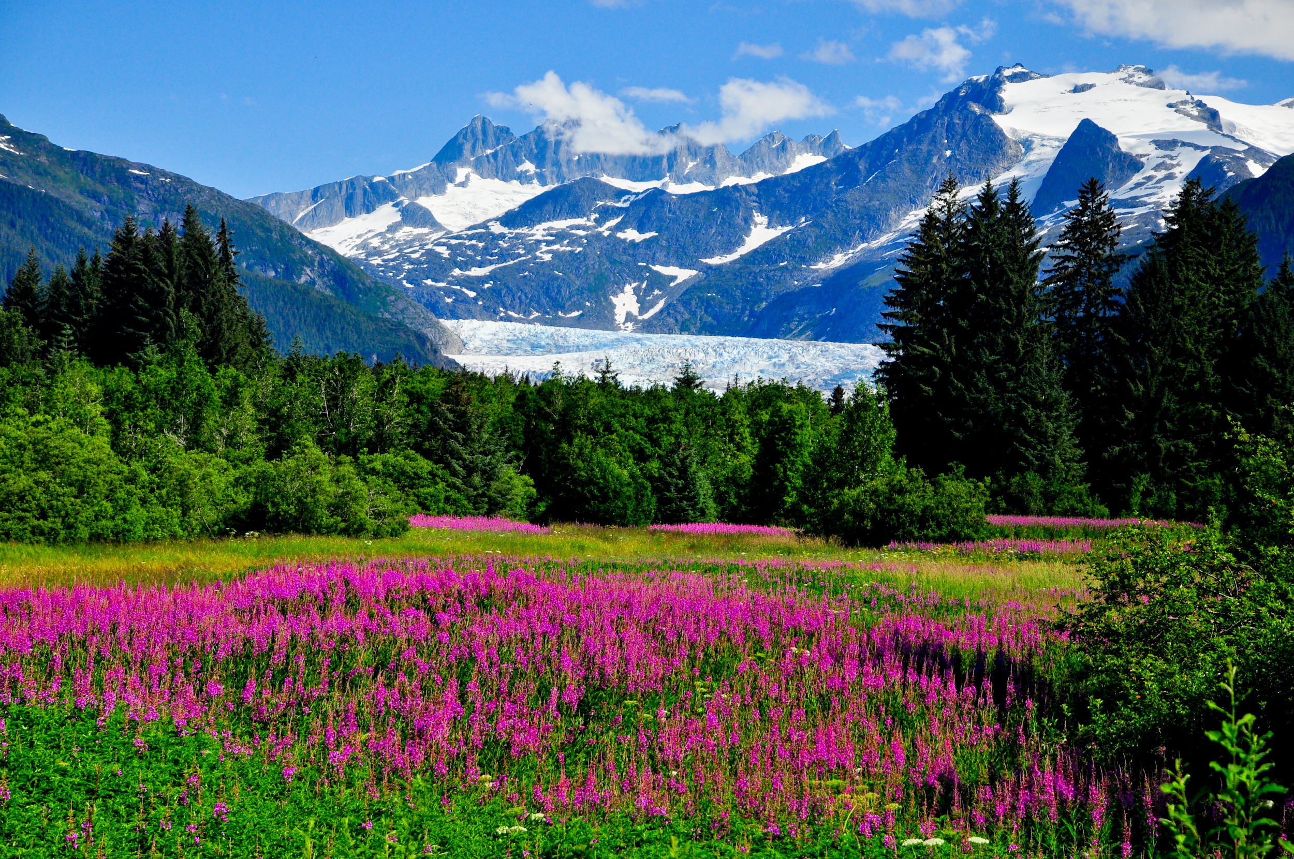

AdventureTime Alaska Tour Guide

Tips & Tricks: Traveling around Alaska may take a long time and be a difficult process because there are little roads and routes. A trip to Alaska can be somewhat pricey because of the activities that you may choose to do. Many excursions and activities are priced very high. In terms of weather, Alaska has four strict seasons, meaning that when it is Winter, you can expect winter-like characteristics such as extreme cold and snow. Cruise’s are a popular way to travel to Alaska, but traveling by land is just as fun. The Northern Lights only appear in the Winter time. Some Animals to be cautious and aware of are Grizzly Bears, Wolves, and Moose.

Must Visit Places : Denali National Park, Tracy Arm Fjord, Kenai Fjords National Park, Alaska Highway, Inside Passage

Must Try Dining: Salty Dawg Saloon, Tommy’s Burger Stop, Sweet Chalet, Dino’s Donuts